Food Management System

Use-Case-Realization Specification: Display Selected Product

Version <1.0>

Revision History

|  |  |  |  |
| --- | --- | --- | --- |
| **Date** | **Version** | **Description** | **Author** |
| <24/12/2020> | <1.1> | Final Draft | Nguyen Thi Ngoc Anh |

Table of Contents

1. Introduction 2

1.1 Purpose 2

1.2 Scope 2

1.3 Definitions, Acronyms, and Abbreviations 2

1.4 References 2

1.5 Overview 2

2. Flow of Events—Design 2

3. Derived Requirements 2

Use-Case-Realization Specification: Display Selected Product

# Introduction

## Purpose

This document describes how the Display Selected Product Use-Case is realized within the design model, in terms of collaborating objects.

## Scope

This document applies to the Food Management System which will be developed by TAT Restaurant.

## Definitions, Acronyms, and Abbreviations

None.

## References

None.

## Overview

In the following section, Use-Case Realization Specification of the Display Selected Product Use-Case of the Food Management System is provided in detail. The first section is a textual description of the Use-Case specification. The following section contains diagrams (sequence and collaboration diagrams) describing how the use case is realized in terms of collaborating objects. The third section includes class diagrams with relationships that participate in the realization of the use case. The last section is an analysis of all requirements, such as non-functional requirements, on the use-case realization that are not considered in the design model, but that need to be taken care of during implementation.

# Flow of Events—Design

**2.1. Use Case Specification (script)**

|  |  |
| --- | --- |
| **Use Case** | Display Selected Product |
| **Description** | Customer displays a list of the products they have selected |
| **Actor(s)** | Customer |
| **Flows of Events** |  |
| **Basic Flow** | | |
| 1. The user goes to display selected products page.  2. The system get all selected products in database as a list.  3. The system displays all the list of items that the user has selected | | |
| **Alternative Flows** | | |
| None. | | |
| **Pre-conditions** | | |
| None. | | |
| **Post-conditions** | | |
| A page lists all selected products in database is displayed for the user. | | |
| **Extension Points** | | |
| Choose Product. | | |

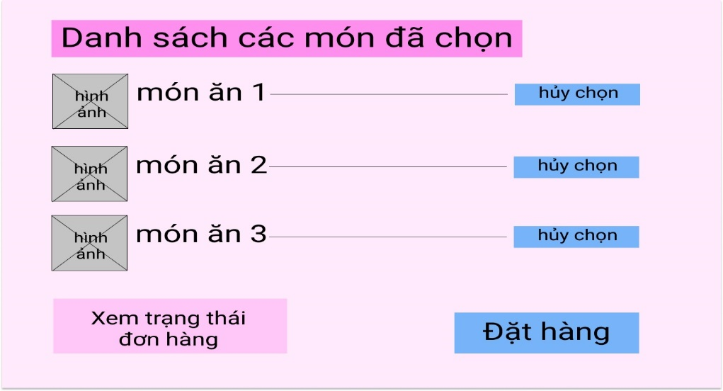

**2.2. Sequence Diagram:**

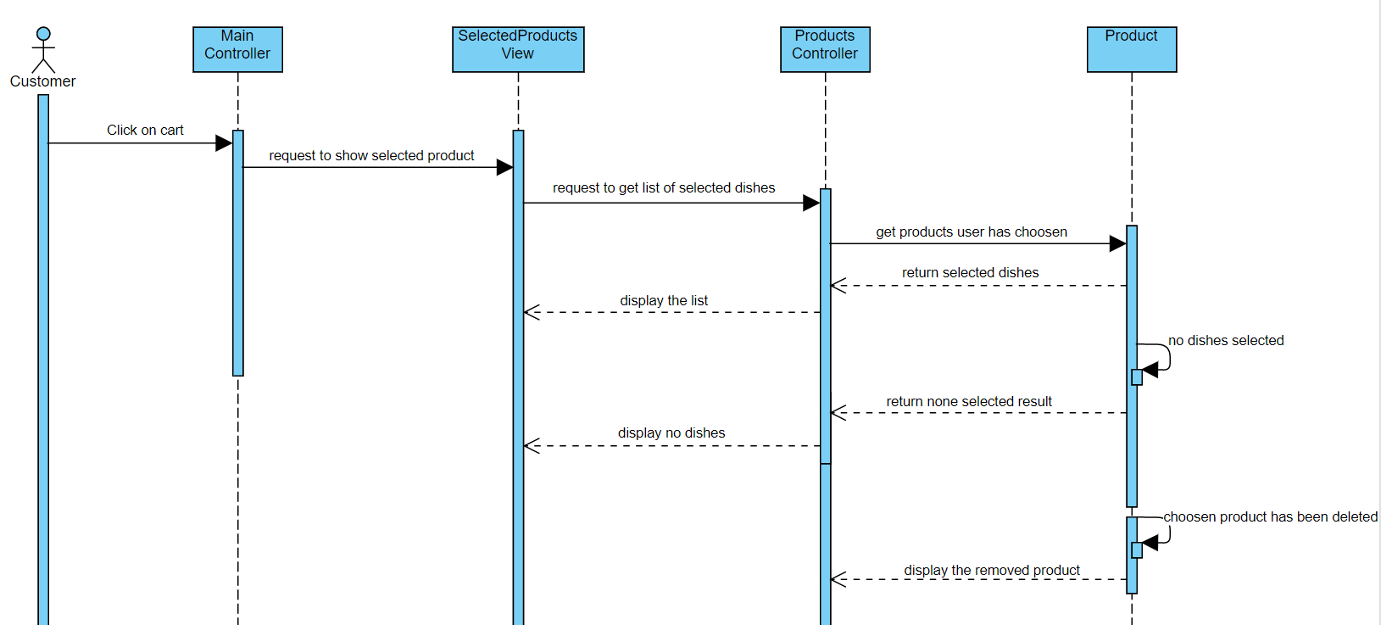

**2.3. Class Diagram:**

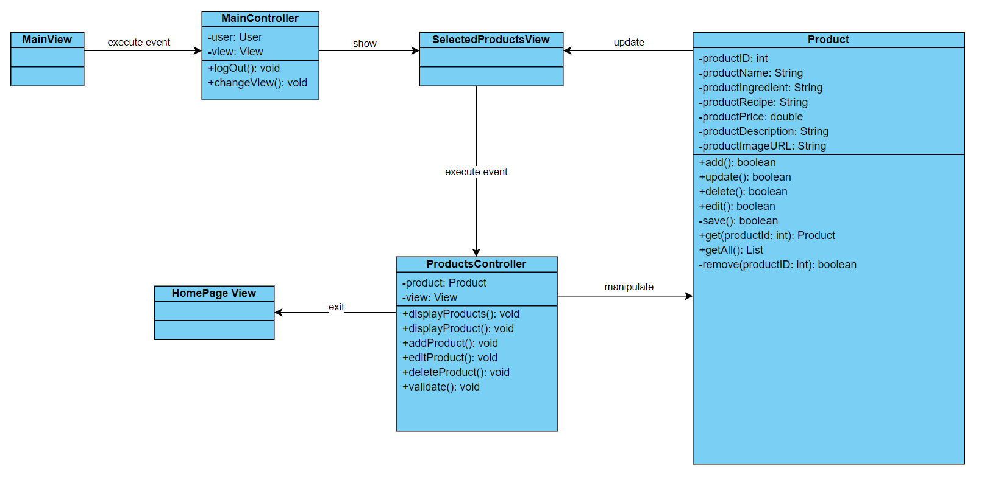

# Derived Requirements

None.